P4
print ("Practical Performed By CB_SP")
num_inputs = int (input ("Enter the number of inputs: "))
print (f"For the (num_inputs) inputs, calculate the net input")
x1, x2, target = [],[],[]
for
in range (num_inputs):
x1. append (int (input ("x1=")))
x2. append (int (input ("x2 = ")))
target. append (int (input ("y=")))
w1 = int (input ("Enter the weight value of input1: "))
w2 = int (input ("Enter the weight value of input2: "))
net_input = [ (w1 * a) + (w2 * b) for a, b in zip(x1, x2)]
print ("Net input")
print ("Yin =", net_input)
Y=[1 if val ›= 1 else 0 for val in net_input]
print ("y =", Y)
print ("T =", target)
if Y == target:
print ("Weight values accepted")
else:
print ("Weights are not suitable.")

Code Logic Explanation (in simple words)
- Inputs and Weights:
We define inputs like x1, x2 as 0 or 1.
We assign equal weights (for example, 1 for each input).
- Threshold for AND gate:
For an AND gate, the output should be 1 only when both inputs are 1.
So, we set the threshold = 2 (since 1+1 = 2).
- Threshold for NOT gate:
The NOT operation has only one input.
It inverts the value — i.e., output = 1 when input = 0.
This can be achieved by using a negative weight and positive threshold.
- Condition Checking:
The program checks whether the sum of weighted inputs is greater than or equal to the threshold.
If yes, output is 1; otherwise, it’s 0.
- Result Display:
The code prints out the truth table showing the AND and NOT outputs.

P5
import numpy as np
print ("Practical Performed By CB_SP")
print ("Enter weights")
w11 = int (input ("weight w11: "))
w12 = int (input ("weight w12: "))
w21 = int (input ("Weight w21: "))
w22 = int (input ("weight w22: "))
v1= int (input (Weight v1: "))
v2 = int (input ("Weight v2: "))
theta = int (input ("Enter threshold value (theta): "))
x1 = np.array ([0, 0, 1, 1])
x2 = np.array([0, 1, 0, 1])
t = np.array([0, 1, 1, O])
zin1 = (x1 * w11) + (x2 * w21)
zin2 = (x1 * w12) + (x2 * w22)
z1 = (zin1 >= theta) .astype (int)
z2 = (zin2 >= theta) .astype (int)
yin = (z1 * v1) + (z2 * v2)
y = (yin >= theta) .astype (int)
print ("\n--- Results ---")
print ("zin1 =", zin1)
print ("zin2 =", zin2)
print ("yin =", yin)
print ("Output (y) =", y)
print ("Target (t) =", t)
if np. array_equal (y, t) :
print ("\n The network output matches the target!")
else:
print ("\n X The network output does NOT match the target.")

Code Logic Explanation (in simple words)
- Basic Idea:
XOR can be expressed using simpler logic gates:
- Implementation Steps:
  - Compute NOT(x1) and NOT(x2) using M-P NOT neuron.
  - Compute AND(x1, NOT(x2)) and AND(NOT(x1), x2) using M-P AND neuron.
  - Finally, combine both using an OR neuron.
- Thresholds:
  - For AND → θ = 2
  - For OR → θ = 1
  - For NOT → negative weight and θ = 0
- Execution:
Each neuron’s output is passed to the next layer to simulate a small network.
This forms the correct XOR truth table.

P6
print ("Practical 3(A) performed by CB_SP")
X = [[1, 1], [1, -1], [-1, 1], [-1, -1]]
print ("Input=")
for x in X:
print (x)
Y=[1, -1, -1, -1]
print ("Target=", Y)
w = [0, 0]
print ("Initial weight values=", w)
for i in range (len (X)) :
for j in range (len (w)) :
w[j] = w[j] + x[i][j] * Y[i]
print (i, "Iteration, weights value=", w)

2) Code logic (step-by-step, simple words)
- Start with weights initialized to zero (or small values) and bias = 0.
- For each training pattern:
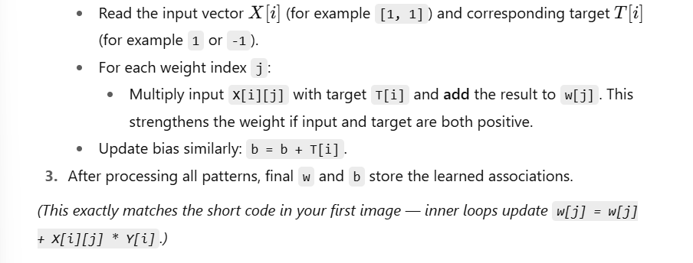

P7

import numpy as np
print ("Practical 3(B) performed by CB SP")
np. set_printoptions (precision=20)
x = np.zeros ( (3, ))
weights = np.zeros ( (3,))
desired = np.zeros ( (3,))
actual = np.zeros ( (3,))

for i in range (0, 3):
x[i] = float (input ("Initial inputs: "))
for i in range (0, 3):
weights[i] = float (input ("Initial weights: "))
for i in range (0, 3):
desired[i] = float (input ("Desired output: "))
for i in range (0, 3):
actual[i] = x[i] * weights[i]
print ("actual", actual)
print ("desired", desired)
a = float (input ("Enter learning rate: "))
while True:
if np.array_equal (desired, actual):
break
else:
for i in range (0, 3):
weights [i] = weights[i] + a * (desired[i] – actual[i])
actual[i] = x[i] * weights[i]
print ("weights", weights)
print ("actual", actual)
print ("desired", desired)
print ("Final output")
print ("Corrected weights", weights)
print ("actual", actual)
print ("desired", desired)
- Initialize weights and bias with small random numbers.
- Take input values X and target outputs T.
- Choose a small learning rate alpha.
- For each input pattern:
  - Calculate the net input = (weights × inputs) + bias
  - Calculate output (y)
  - Find error = target − output
  - Update each weight and bias using the delta formula.
- Repeat for a few epochs (iterations).
- Stop when the outputs match the targets.

P8
print ("Practical 5 (A) performed by CB_SP")
print ("=== Membership Operators ===")
fruits = ["apple", "banana", "cherry"]
print("banana in fruits:", "banana" in fruits)
print ("mango in fruits:", "mango" in fruits)
print ("mango not in fruits:", "mango" not in fruits)
print ("apple not in fruits:", "apple" not in fruits)
Logic Explanation:
- A membership operator is used to check whether a value exists inside a sequence like a list, string, or tuple.
- in → returns True if the value is present.
- not in → returns True if the value is not present.
In this code:
- "banana" in fruits → True (because banana is in the list)
- "mango" in fruits → False (mango is not in the list)
- "mango" not in fruits → True
- "apple" not in fruits → False (apple is present)

print ("Practical 5 (B) performed by CB_SP")
print("\n=== Identity Operators ===")
× = [1, 2, 3]
У = [1, 2, 3]
Z = x
print ("x is y:", × is y)
print ("x is z:", X is z)
print("x is not y:", × is not y)
print ("x is not z:", x is not z)
Logic Explanation:
- Identity operators compare object identity, not content.
- is → returns True if both variables point to the same memory location.
- is not → returns True if they are different objects in memory.
In this code:
- x and y have the same values but are different objects → x is y → False.
- z = x means both point to the same object → x is z → True.

'''A university library maintains a digital database of registered students
and their borrowed books. Checks whether the book "Python Programming" is present in the library's
collection using a membership operator. Creates two student records with the same details but as separate objects,
and compares them using an identity operator "'
print ("Practical 5 (C) performed by CB_SP")
library_books - ["Data Science", "Soft Computing", "Research", "Blockchain"]
requested _book = "Soft Computing"
# --- Membership Operators (in, not in) ---
print ("=== Membership Operators ==")
if requested_book in library_books:
print (f" ’ (requested book)' is available in the library.")
else:
print (f" '(requested book)' is NOT available in the library.")
if "Image Processing" not in library_books:
print (" 'Image Processing' is not in the library database.")
print ("\n=== Identity Operators =")
student1 = ("name": "umayer", "id": 101)
student2 = {"name": "shaikh", "id"; 101)|
student3 = student1
print("student1 is student2:", student1 is student2)
print("student1 is student3:", student1 is student3)
print("student1 is not student2:", student1 is not student2)
print ("student1 is not student3:", student1 is not student3)
Logic Explanation:
- The membership part checks if "Soft Computing" is present in the library’s list.
  - If yes → It prints that the book is available.
  - If not → It prints that the book is not available.
- The identity part checks if two student records refer to the same object.
  - student1 and student2 have same data but are different objects → is gives False.
  - student1 and student3 refer to same object → is gives True.

